**Writing code in IntelliJ to finish the following Programming Exercises in textbook.**

**To receive full-mark of the lab, please show me your code and running results.**

1. **Exercise 3.22**

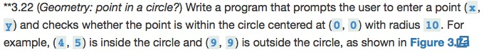

1. **Exercise 4.1**

1. **Exercise 5.44**

**(You can assume the short integer is non-negative)**